
RAMAIAH
INSTITUTE OF TECHNOLOGY
USN | 1 | M | S

(Autonomous Institute, Affiliated to VTU)
Bangalore – 560 054

MAKEUP EXAMINATIONS – MAY/JUNE 2017

Course & Branch | : | B.E : Computer Science and Engineering | Semester | : | IV
Subject | : | Design and Analysis of Algorithm | Max. Marks | : | 100
Subject Code | : | CS1542/CS413 | Duration | : | 3 Hrs

Instructions to the Candidates:
- Answer one full question from each unit.

 |  | UNIT - I
1. | a) | Identify the stable matching set of men and women for the following preference list. | CO1 | (06)
  Men’s Preference List |  |  |  |  |  | Women’s Preference List
   | 1 | 2 | 3 | 4 |  |  | 1 | 2 | 3 | 4
  A | X | Y | W | Z |  | W | C | A | B | D
  B | Z | X | Y | W |  | X | B | D | A | C
  C | Y | Z | X | W |  | Y | A | D | C | B
  D | Y | W | X | Z |  | Z | C | D | A | B
 | b) | Illustrate whether the following statements are true or false. Give justification.  [O – Big Oh, Θ – Big Theta, Ω - Big Omega ]  - n(n + 1)/2 Є O(n^3)  - n(n + 1)/2 Є Θ(n^3)  - n(n + 1)/2 Є Ω(n) | CO1 | (06)
 | c) | Prove that “Every execution of the G-S algorithm results in the set S*”. | CO6 | (08)
2 | a) | Design an algorithm to find stable matching in a given n men & n women sets. What is the worst case input for the algorithm? | CO1 | (06)
 | b) | Examine how the running time of an algorithm which finds independent sets in a graph takes O(n^k) time. | CO6 | (06)
 | c) | Describe five representative problems. | CO1 | (08)
 |  | UNIT - II
3. | a) | - Identify the number of inversions for the array {9,10,3,4,8,2,15,3,2,1} using divide and conquer method.  - Design an algorithm for depth-first search using recursion approach. | CO3 | (10)
 | b) | - For a given graph G=(V,E) prove that, “If G has a topological ordering, then G is a DAG.”  - Construct the DFS traversal for the following with source as 1.  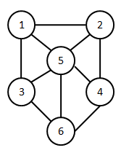 | CO2 | (10)
4. | a) | - Construct the BFS traversal for the following graph with source as ‘a’.  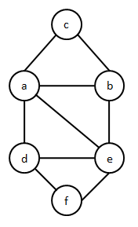  - Prove that the time complexity of merge sort is O(n log n) using “unrolling method”. | CO2 | (10)
 | b) | - Design an algorithm to sort n numbers using divide and conquer approach.  - Let G be a connected graph, and let L1, L2, . . . be the layers produced by BFS starting at node s. Prove that G is bipartite or not using the layers L1,L2… | CO3 | (10)
 |  | UNIT - III
5. | a) | - Design a greedy algorithm to schedule the given intervals with each interval having a start time s_{i} and finish times f_{i}.  - Construct the minimum spanning tree for the following graph using Prim’s algorithm.  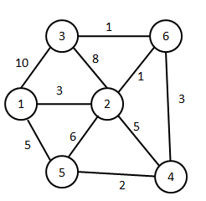 | CO4 | (10)
 | b) | - Identify the optimal set of intervals that can be scheduled for the following set on intervals using greedy interval scheduling algorithm.  - Design an algorithm to determine the optimal prefix code for a given set of alphabets and their respective frequencies. | CO4 | (10)
  Intervals | Start time | Finish time
  1 | 1 | 20
  2 | 23 | 30
  3 | 1 | 4
  4 | 6 | 10
  5 | 14 | 18
  6 | 21 | 35
  7 | 1 | 9
  8 | 16 | 15
  9 | 17 | 19
6. | a) | - Identify the shortest path from source node 1 to all other nodes for the following graph using Dijkstra’s algorithm.  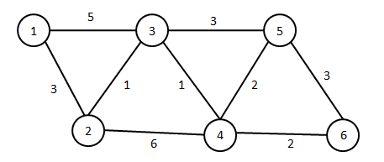  - Design a greedy algorithm to schedule the given intervals with each interval having a deadline time d_{i} and time interval t_{i}. | CO4 | (10)
 | b) | - Construct the optimal prefix code for S={a,b,c,d,e} and frequencies f_{a}=0.32, f_{b}=0.25, f_{c}=0.20, f_{d}=0.18, f_{e}=0.05.  - Design Prim's algorithm to determine the minimum spanning tree using the given graph G=(V,E). | CO4 | (10)
 |  | UNIT – IV
7. | a) | Construct the shortest path for the given graph using Bellman Ford algorithm. Assume vertex “0” as the source.  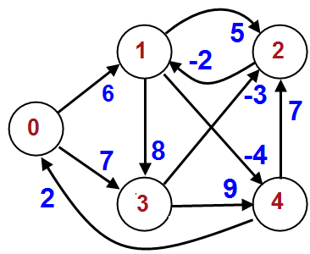 | CO4 | (10)
 | b) | Write the Memoization algorithm for interval scheduling. List its advantages. | CO4 | (04)
 | c) | Describe the survey design problem. | CO4 | (06)
8. | a) | Apply the Ford-Fulkerson algorithm to find the maximum flow for the following graph.  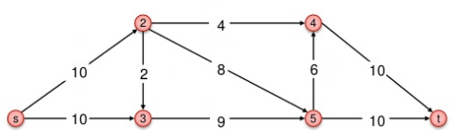 | CO4 | (08)
 | b) | Write the algorithm for Knapsack problem. Show the recurrence relation used in the Knapsack problem. | CO4 | (06)
 | c) | Describe the Airline scheduling problem. | CO4 | (06)
 |  | UNIT - V
9. | a) | Define P, NP, NP-complete and NP-Hard. | CO5 | (04)
 | b) | Discuss Travelling salesman problem. Justify that travelling salesman problem is NP-Complete. | CO5 | (10)
 | c) | What do you mean by polynomial time reduction? Give a correlation between vertex-cover and independent set problem. | CO5 | (06)
10. | a) | Discuss circuit satisfiability problem and prove that it is NP-Complete. | CO5 | (10)
 | b) | Compute Hamiltonian cycle for the following graph starting at A and then at D and compare the result.  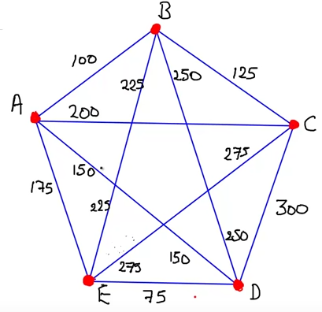 | CO5 | (10)
****************

